Question 01:

Code

#include<stdio.h>

void myFunction(int num1, int num2);

void main (void){

int num1,num2;

num1=num2=0;

printf("You have to input two numbers\n");

printf("Enter the 1st Number: \n");

scanf("%d",&num1);

printf("Enter the 2nd Number: \n");

scanf("%d",&num2);

myFunction(num1,num2);

}

void myFunction(int num1, int num2){

int temp=0;

temp=num1;

num1=num2;

num2=temp;

printf("The swapped numbers are %d and %d",num1,num2);

}

Output

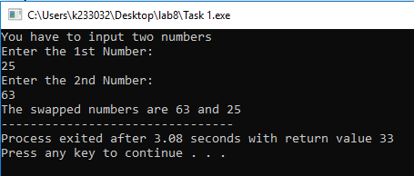

Question 02:

Code

#include<stdio.h>

void ADDITION (int num1, int num2);

void SUBTRACTION (int num1, int num2);

void MULTIPLICATION (int num1, int num2);

void DIVISION (int num1, int num2);

void main (void){

char choice;

int num1, num2,answer;

num1=num2=answer=0;

printf("You have to enter two numbers: \n");

printf("Enter the first number: \n");

scanf("%d",&num1);

printf("Enter the second number: \n");

scanf("%d",&num2);

printf("What do you want to perform? A=Addition S=Subtraction M=Multiplication D=Division");

choice=getche();

if (choice=='A'){

ADDITION(num1,num2);

}

else if(choice=='S'){

SUBTRACTION(num1, num2);

}

else if(choice=='M'){

MULTIPLICATION(num1, num2);

}

else if(choice=='D'){

DIVISION(num1, num2);

}

}

void ADDITION(int num1, int num2){

int answer=num1+num2;

printf("\nThe sum of the two numbers %d and %d is %d\n",num1,num2,answer);

}

void SUBTRACTION(int num1, int num2){

int answer=num1-num2;

printf("\nThe subtraction of the two numbers %d and %d is %d\n",num1,num2,answer);

}

void MULTIPLICATION(int num1, int num2){

int answer=num1\*num2;

printf("\nThe multiplication of the two numbers %d and %d is %d\n",num1,num2,answer);

}

void DIVISION(int num1, int num2){

int answer=num1/num2;

printf("\nThe division of the two numbers %d and %d is %d\n",num1,num2,answer);

}

Output

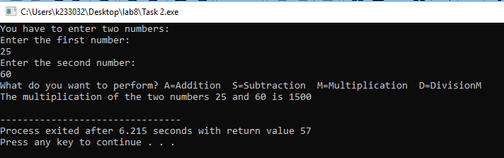

Question 03:

Code

#include<stdio.h>

#include<string.h>

void main(void){

char text[500], search;

int count;

count=0;

printf("Enter your text: \n");

gets(text);

printf("Enter the character you want to search for in your text: \n");

search=getchar();

for (int i=0; text[i]!='\0'; i++){

if (text[i]==search){

count++;

}

}

printf("The character '%c' comes %d time in your text\n",search,count);

}

Output

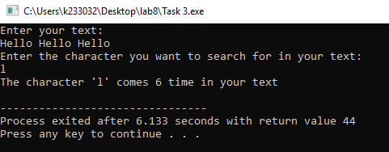

Question 04:

Code

#include <stdio.h>

#include <string.h>

void main(void){

char password[200];

char storedpassword[200];

int count=0, ret=0;

printf("Enter the password to store it: \n");

gets(storedpassword);

printf("Enter your password: \n");

gets(password);

int i=0;

while (password[i]!='\0'){

count++;

i++;

}

ret=strcmp(password,storedpassword);

if (count>=8 && ret==0)

printf("Login Successful. Welcome!\n");

else

printf("Login Failed. Invalid Password");

}

Output

